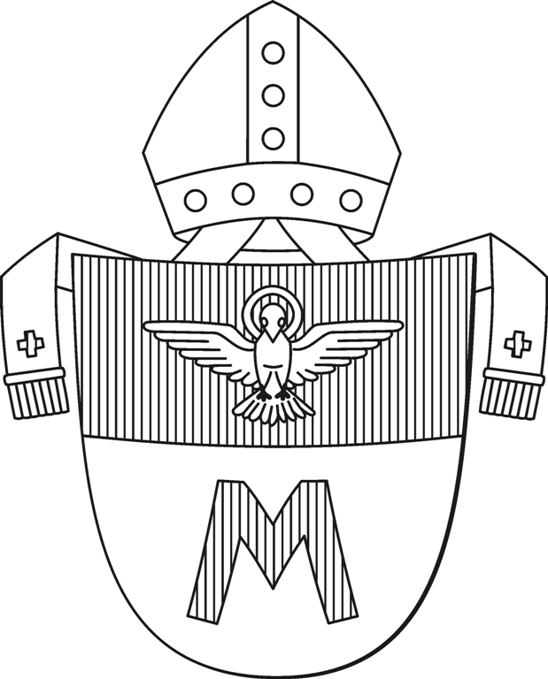
Diocese of Hradec králové

Velké náměstí 35, 500 01 Hradec Králové Diocesan conservation centre
E-Mail: pamatky@bihk.cz
Telephone No.: 495 063 673

Complete the name and address to send the approval:

Request for an approval forresearch / publication activities

To be filled out by the Diocese Hradec Králové

Permission with the research / publication activity

The Diocese Hradec Králové agrees, that the below mentioned applicant was granted a permission to make research / publication activities under the mentioned conditions and under the mentioned purpose, comprising of the following:

- a visit and a tour of the historical sight yes / no
the permission applies to the object´sserial No.:

- making a photographic documentation yes / no
the permission applies to the object´sserial No.:

- a consultation of the respective documentation of the National Heritage Board yes / no
the permission applies to the object´sserial No.:

- a publication of the made photographic documentation yes / no
the permission applies to the object´sserial No.:

- the transmission and the publication of the below mentioned requested photographic documentation after the approval of the transmission and after the agreement of the conditions with the owner of the photographic documentation, who is: ................................................................... yes / no
the permission applies to the object´sserial No.:

In Hradec Králové on the:
Reference No.:

_______________________________
Mons. Mgr. Jan Paseka, vicar-general

To be filled out by the applicant
Applicant – a natural person
Surname, Name, degree:
Address of permanent residence:
Date of birth:
Telephone No.:
E-Mail:
Institution (name and address of the institution or school):

Applicant - a legal person
Name of the institution:
Address of the registered established residence office:
Company identification number ID No.:
Statutory representative:
Contact person:
Telephone No.:
E-Mail:

Photographer–fill out in the case that another person will be making the photographic documentation in the absence of the applicant
Surname, Name, degree:
Telephone No.:
E-Mail:
Institution:

(The request to access documentation is not valid for the photographer.)

Topic of the research activity (title of the study, lecture, monograph):

Publishing form:
researchwork (seminary, bachelor diploma thesis, master diploma thesis, dissertation, scientific studyetc.)
lecture
printed – periodical
printed – monograph
other (electronic media, exhibitionetc.)

Nature of the publication:
research work
commercial
educational non-profit
promotional

Estimated publication / release date (month, year):

Estimated number of copies:

The research activity will include:
a visit and a tour of the historical sight
making a photographic documentation
a consultation of the particular documentation of the National Heritage Board
an approval to an assumption of the photographic documentation for the specified publication purpose

To be filled out by the applicant
Subject of the research activity
(If the specified number of boxes is not sufficient, make a photocopy of the given structure onto a separate sheet)

1. Object (name of the parish / location, name of the building):
Subject:
Estimated number of made photographs: Approved by the parish on the:

2. Object (name of the parish / location, name of the building):
Subject:
Estimated number of made photographs: Approved by the parish on the:

3. Object (name of the parish / location, name of the building):
Subject:
Estimated number of made photographs: Approved by the parish on the:

Specify the subject more in detail(for example the architecture of the church, paintings of a concrete artist, a long-distance shot of the interior etc.).
The applicant is required to seek prior approval from the respective parish;the most convenient form is via electronic mail. A copy of the approval of all affected parishes has to be enclosed to the request. A summary of the municipalities / locations / parishes belonging to the Diocese of Hradec Králové and their affiliation to the parish constituency is available onour website www.bihk.cz

To be filled out by the Diocese Hradec Králové
Requirements stipulated for the implementation of the research / publication activity:
- The period of validity of this permission for the visit of the historical sight is 3 months from the day of its issue with the possibility of an extension of the validity on the basis of an approval by the Diocese Hradec Králové. In the case of the made photographic documentary is the period of the validity of the approval restricted to its first publication.

- It is necessary to fix a dayin advance for the date of the visit with a representative of the owner of the real property / object, i.e. with the ecclesiastical administrator of the respective parish.

- An examination of the subject of the research activity will take place in the presence of an ecclesiastical administrator of the respective parish or an authorised person.

- The applicant will identify himself to the ecclesiastical administrator of the respective parish by means of his identity card and by way of this permission.

- The photographic documentation can be made only in the extent appropriate for the subject of the research activity. (Only those pieces of art can be photographed, which are directly connected to the subject of the research activity; if the subject of the research activity is the architecture of the object, than no close-up shots of the furniture must be made.)

- The photographic documentation may be used exclusively for research purposes by the applicant and can be published only in the specified extent and for the given purpose. Without an approval of a representative of the owner of the object and the Diocese Hradec Králové no other publication must be neither made nor otherwise released.

- The applicant is obligated to hand over the entire photographic documentation to the respective parish and to the Diocese Hradec Králové for internal purposes and for a non-commercial promotion with the stated authorship of the photographs.

- The applicant is obligated to hand over his / her research or publication work / output to the respective parish and to the Diocese Hradec Králové.
- In the case of a study work or unpublished research work will the applicant send the study work including the photographic documentary in electronic form to the E-Mail address: pamatky@bihk.cz, and that until the date mentioned as the estimated date of finishing the research activity at the very latest.
- In the case of the published work the applicant transfers that to the:
- respective parishin ……………………….copies of the printouts immediately after their publishing
- Diocese Hradec Králové in ………………….copies of the printouts immediately after their publishing

Requirements stipulated for the transfer of the documentation:
- The transfer of the photographic documentation is bound by the conditions of the owner of the photographic documentation.

Specific conditions:

To be filled out by the applicant
- The applicant confirms with his / her signature, that
- He / she was informed about sensitive information and according to this he / she will handle those pieces of information;
- He / she remains silent about facts, which serves as security protection of the historical / cultural sights / monuments;
- He / she remains silent about the worth of the documented cultural sights;
- He / she is aware about material and criminal sanctions, if he / she breaks his / her obligation.

- The applicant confirms thereinafter with his / her signature, that he / she was informed about all conditions, by whose fulfilment can the research visit be carried out, appropriately the publication of the made photographic documentation and he / she is obligated to keep those conditions. A non-observance of these conditions, especially the preservation of thereverence to the location and to the instructions of the representatives of the Roman Catholic parish can be a reason to withdraw the approval for the photographing.

- The applicantis also obligated, that all made photographs are used only for the above mentioned purposes.

- The applicant declares that all stated pieces of information and provided personal data are truthful.

- The Producer acknowledges that if he or she is a natural person, the Roman Catholic Parish is an administrator of their personal data pursuant to the General Data Protection Regulation (GDPR) of the European Parliament and of the Council (EU) 2016/679 and any subsequent legal regulations. The authorization of the Roman Catholic Parish to administer personal data results directly from this contract within the extent and scope that is necessary for its conclusion and performance, for the performance of related legal obligations and in pursuance of justified interests of the Roman Catholic Parish. This data processing is not subject to any special approval. Based on its justified interest the Roman Catholic Parish shares the personal data within necessary extent and scope with the Diocese of Hradec Králové which gives its approval to the contract. The Producer is obliged to inform any data entity whose personal data is also mentioned in the contract about the personal data processing procedure. The Producer declares that he or she is aware of his or her rights to have access to the processed personal data on application for information about his or her personal data that is processed and in which way it is processed, on application for specifying, amending and updating the data, and also he or she is aware of his or her right to interpose an objection against data processing, to apply for limiting data processing, for deleting any illegally processed data or to make a complaint at the Office for Personal Data Protection. In all matters concerning personal data he or she may approach a data protection commissioner whose contact details are available at www.bihk.cz in the Contacts Section.

- The applicant confirms with his / her signature, that he / she fully understands the following stated below:
- The research workers are obligated to observe safety, fire, hygienic and ecological regulations during the activities conducted in the objects and premises within the grounds of the ecclesiastical entities.
- The research workers enter on their own request generallyinaccessible premises / spaces. The entrance into those premises is allowed only on their own account, risk.
- Within the objects of the ecclesiastic entities there is aban on smoking and on alcohol and other addictive drugs. It is also forbidden to walk under suspended weights.
- The research workers are obligated to use their own personal protective working means according to the risks, to which they are exposed during the performance of activities connected to their study research.
- All damages, which are caused during the activity of the research workers, must be reported immediately to the statutory representative of the ecclesiastic entity.
- It is necessary to report emerged injuries to the statutory representative of the ecclesiastic entity – a written record about the injury has to be drawn up.

Date and place of the signature:
______________________________
Signature and stamp of the applicant

The completed and signed Request for a research / publication approvalis to be sent in two copies with all the obligatory supplements by mail to the address:

Diocese Hradec Králové
Velké náměstí 35, 500 01 Hradec Králové

Obligatory supplements:
- The student certificate or a certificate of employment in the affected institution
- An approval with the personal data processing and the safety measures instructions protocol of the photographer in case that the photographing person is not the same as the applicant – the form Permission forprocessingpersonal data and the Protocol about the safety measures instructionsis available for download at the website address: here
- a copy of the approval of the respective parish

Notification:
Incompletely or incorrectly filled out requests and applications without the necessary supplements, or mere photocopies and scans of applications does the Diocese Hradec Králové not take into consideration and those requests are being destroyed, shredded.

