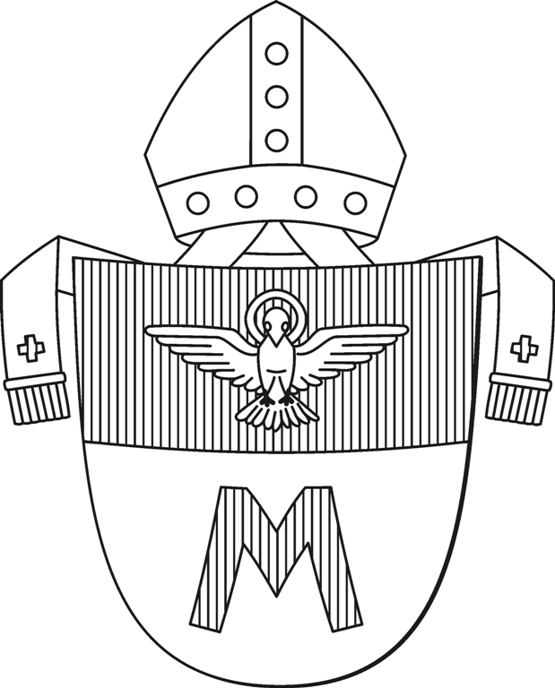
Diocese of Hradec králové

Velké náměstí 35, 500 01 Hradec Králové Diocesan conservation centre
E-Mail: pamatky@bihk.cz
Tel. No.: 0042 0 495 063 673

Request for authorisation to make film shootings

To be completed by the applicant:
Applicant - a natural person
Surname, Name, degree:
Address of permanent residence:
Date of birth:
Telephone No.:
E-Mail:
Institution (name and address of the institution or school):
Applicant - a legal person
Name of the institution:
Address of the registered established residence office:
Company identification number ID No.:
Tax identification registration No.:
Statutory representative:
Contact person:
Telephone No.:
E-Mail:
Character of the resulting film work:
Commercial
Educational non-profit
Promotional
Genre of the film work:
(for example: a travelogue, a documentary, a featured film etc.)
Main topic:
Working title:
How will it be distributed?
How will it be shown, projected to the public (for example: by a television station in the Czech Republic, in a cinema in the Czech Republic, in schools in the Czech Republic etc.):
Estimated release date (month, year):
Estimated shooting date (day, month and year):
(If the filming takes up more shooting days, please specify the beginning and also the end of the film shooting)
Estimated number of people, crew who will participate in the shooting:
The applicant declares that all the given information is truthful.

Subject of the film shooting activity:
(If the specified number of boxes is not sufficient, make a photocopy of the given structure onto a separate sheet)
- Object:
(name of the parish / location, name of the building)
Subject:
Estimated length of the film shooting in minutes:
- Object:
(name of the parish / location, name of the building)
Subject:
Estimated length of the film shooting in minutes:
- Object:
(name of the parish / location, name of the building)
Subject:
Estimated length of the film shooting in minutes:
Specify the subject more in detail (for example: architecture of the church, paintings of a concrete artist, a long-distance shot of the interior etc.).

The applicant is required to seek prior approval from the respective parish. A summary of the municipalities / locations / parishes belonging to the Diocese of Hradec Králové and their affiliation to the parish constituency is available on our website: www.bihk.cz

The completed Request for authorisation to make film shootings is to be send by electronic mail to the address: pamatky@bihk.cz

Only properly and completely filled out forms will be accepted for the authorisation procedure for making film shootings.

In the case of an approval of the request you will be sent a Contract for cooperation while realising film shootings.

